**FUNCTIONAL REQUIREMENTS FOR MP3 PLAYER**

**Features supported for the user:**

1. User Login
2. Play and Pause Songs
3. Create Playlists
4. Add Favourites

**1. User Login**

Once a user provides its details and a profile is set up, the user needs to login in order to avail all functionalities provided on the platform. When a customer logs into the platform using their assigned ID and password, they reach the main page where they can make use of the platform functionalities.

**2. Play and Pause Songs**

The user should be able to play all songs available on the app and pause, rewind and fast forward as per his or her wish.

1. **Create Playlist**

The user should be able to create a playlist of songs of their choice, where after one song ends it should be followed by the next song in the playlist. All the playlists created by the user should be displayed on the main page. The user should be able to edit songs in the playlists as well as remove the whole playlist if he or she wishes so.

1. **Add Favourites**

The user can select songs of their choice and mark them as favourites. These favourites should be displayed on the main page separately. Songs can be marked as ‘Favourite’ by tapping the heart icon above each song.

**Workflow:**

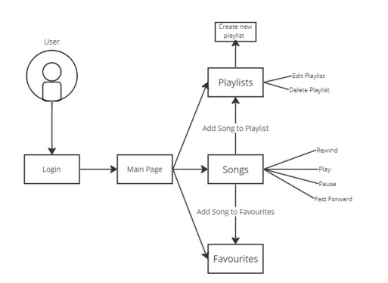

**Fig-1: User Workflow**

|  |  |
| --- | --- |
| Main Page | Views songs and favourites and playlists, if the user has created any |
| Play Songs | Play, pause, and rewind songs |
| Playlists | Create and edit playlists |
| Favourites | Mark any song as favourites |